**While creating a broker, we can configure it like setting username, passwords, protocols and many more things.**

We can check what are all these configurations could be using the command

**bin>artemis help create**

O/P:

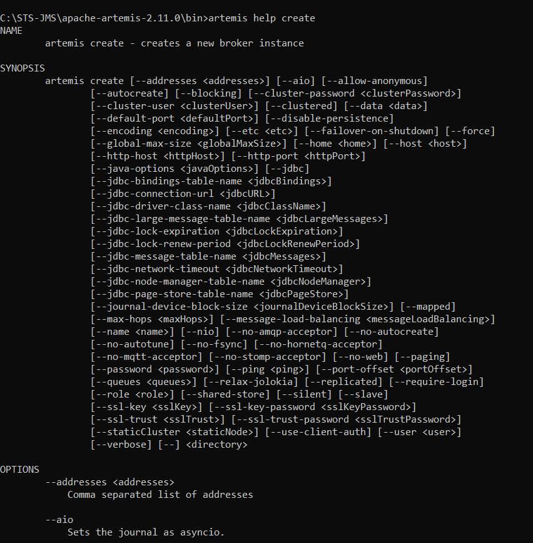

**Like how to disable protocols (acceptors)**

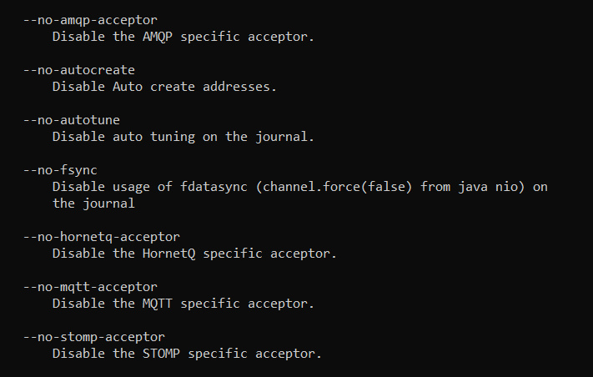

**For example, I am going to create a broker with disabled AMQP acceptor**

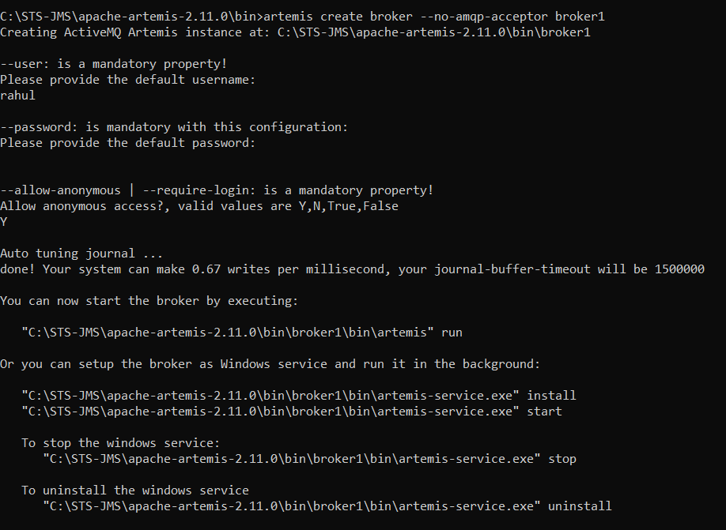

**As I have created a broker with disabled AMQP acceptor, lets check it by starting the server.**

